30 | 20 | 50 | 100 | Grade
Class:8

Name SUMMATIVE ASSESMENT-1 SET-B
Roll No: Total marks:20
______________________________________________________________________________________________
1 Write the following components of the open-shot interface. 1/2x10=5M
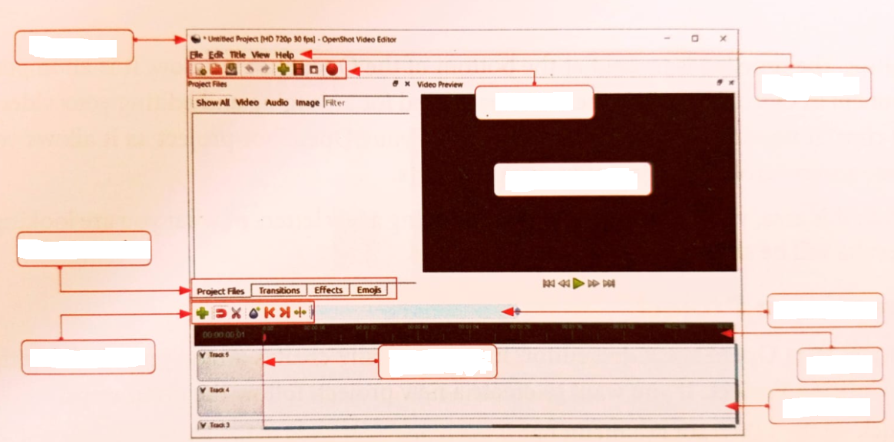
2.Fill in the blanks 1x5=5M
1. The _________________ from screens can delay your sleep.
2.__________________ is the workspace used for arranging and editing your video and audio.
3. In a relational database, data is stored in ________________________
4. A__________________ stores logically organised data.
5. __________________ is the area where you can watch your video as you work on it.
3. state whether the following statements are true or false. 1x5=5M
1. DBMS stands for Data Base making system. ( )
2. A cheerful photo online always means the person is feeling happy in real life. ( )
3. Open Shot can only be used to edit audio files. ( )
4. Null values are allowed in a primary key. ( )
5.Transitions can only be added to audio clips. ( )

4. Select the correct option. 1x3=3M
1.Which part of an application user see and interact with?
a. Frontend b. Backend c. Database
2.What happens when you press ctrl+N in open shot?
a.SaveFile b. Open File c. New Project
3. Which of the following file types is used to save open shot project files?
a. .mp4 b. .osp c. .video
5.Answer any 1 question of the following. 2x1=2M
1. write the query to see all the records of a table named students.
2. what is the purpose of a foreign key?

